**12-14 notes**

Intro to JavaScript visualizations

Goals:

* Describe JavaScript variables, arrays, data types, and statements.
* Implement basic JavaScript control flow (functions, loops, if/else statements).
* Create functions in JavaScript.
* Create, update, and iterate JavaScript objects.
* Create basic charts, including bar charts and line charts, by using Plotly.
* Use Plotly's layout object to customize the appearance of charts.
* Annotate charts with labels, text, and hover text.

Manish in Zoom chat 12/14 6:29pm:

I will Inform Courtney and Jill at Edx that I had given one week delay on homework 12 (as agreed by Jill). However, you can also leave a note in the homework submission, if you like. After all that precautionary measure, if you still get penalized, we will ensure to take up the matter.

JS is mostly used for interaction on the browser level for the user. No ping because it’s all user-side.

The point is to reduce number of requests on a hosting database.

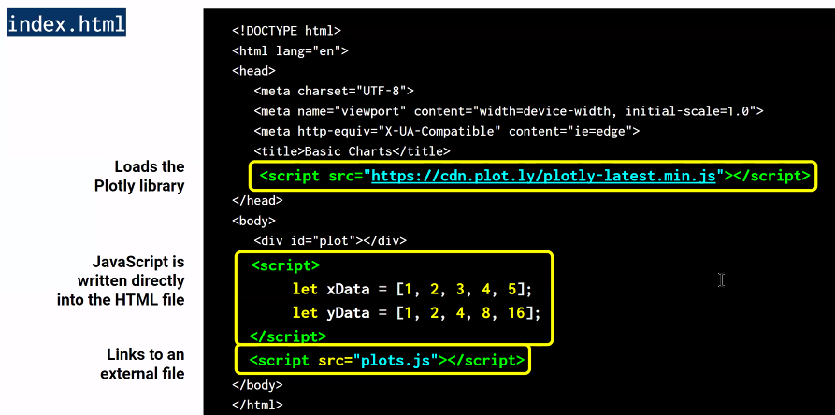

Loading the Plotly library is like an import in Jupyter notebook.

Let is equivalent to For in python.

JS is generally in a JS file, not within the HTML.

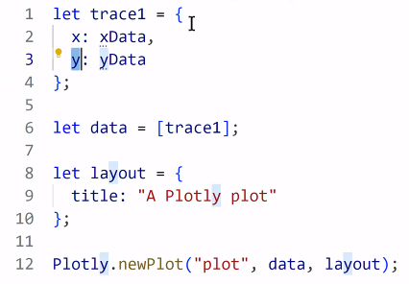

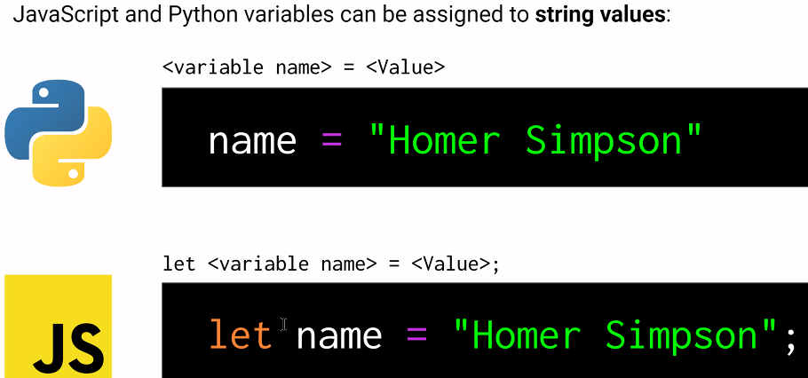

^ No Self-assigning. Need “Let”

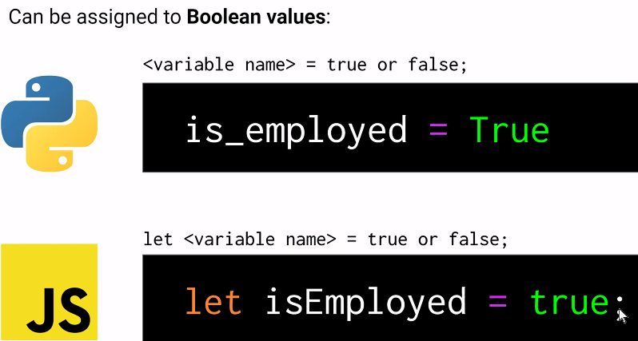

^ Lowercase T for true, and Uses Let

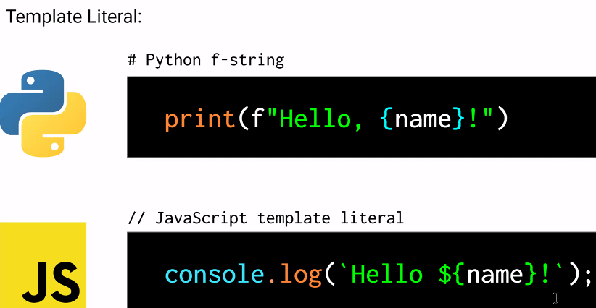

^ console.log adds the record to the console log (F12) in lower right corner.

It’s similar to a print statement.

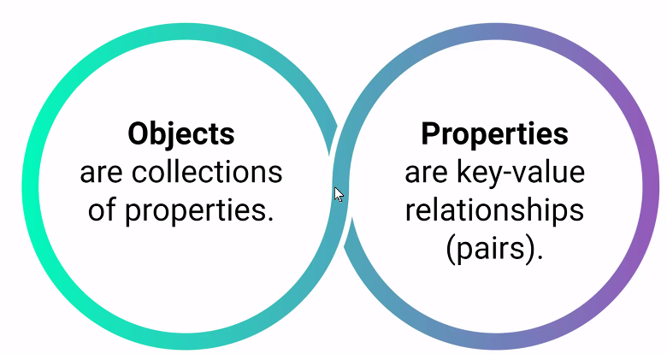

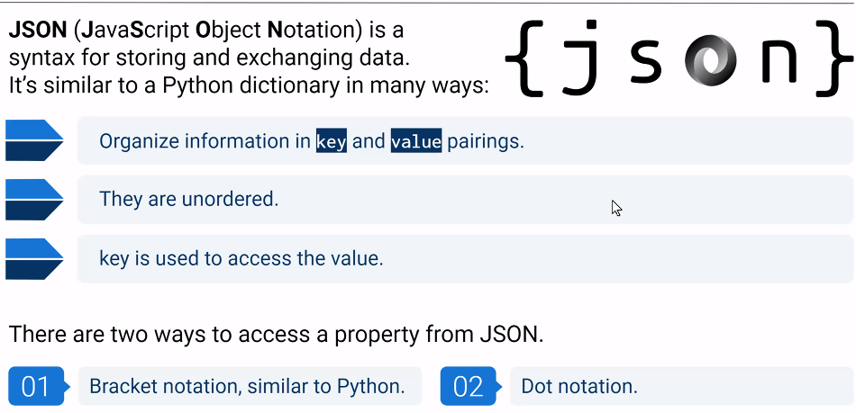

Dot notation is preferred in JS.

**Ins JavaScript Variables Solution:**

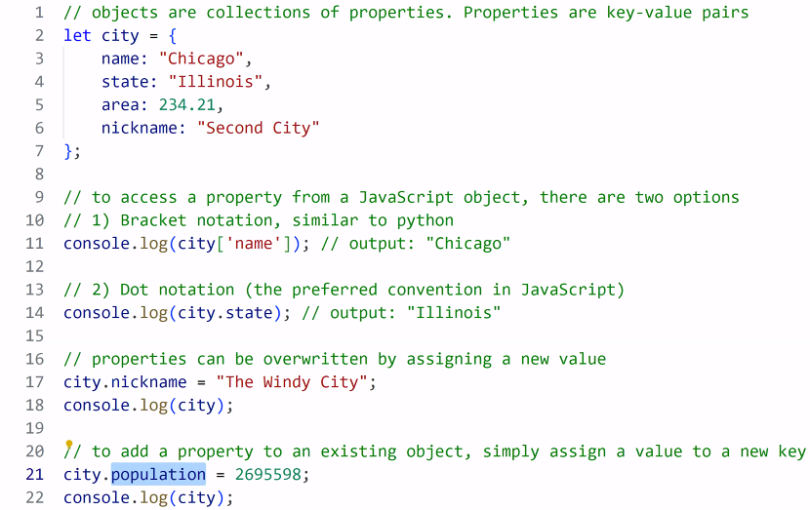

^ Line 21- You can add a property without the let statement

**Hello Variable World Solution:**

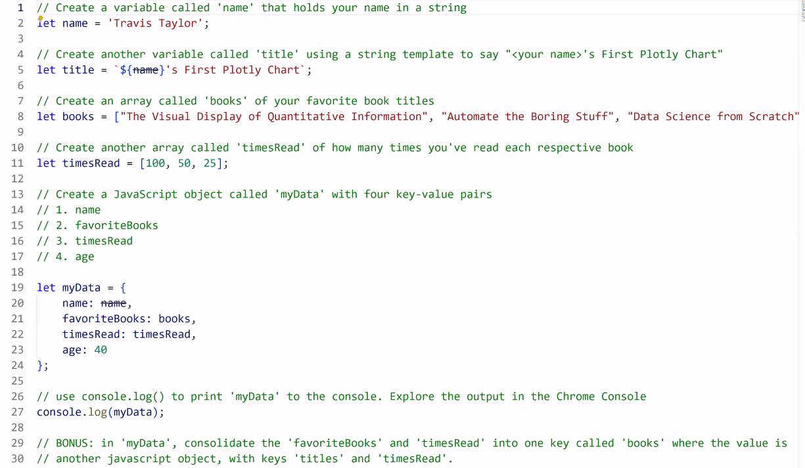

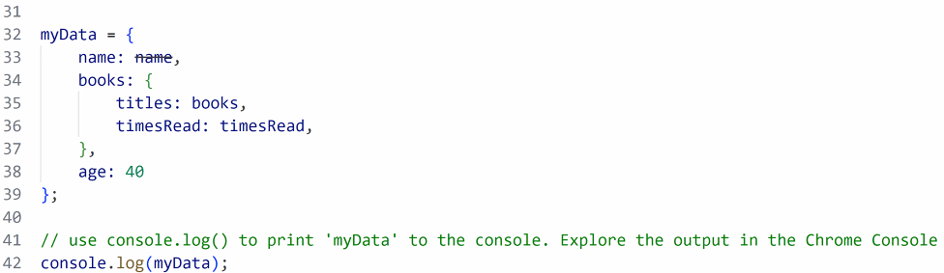

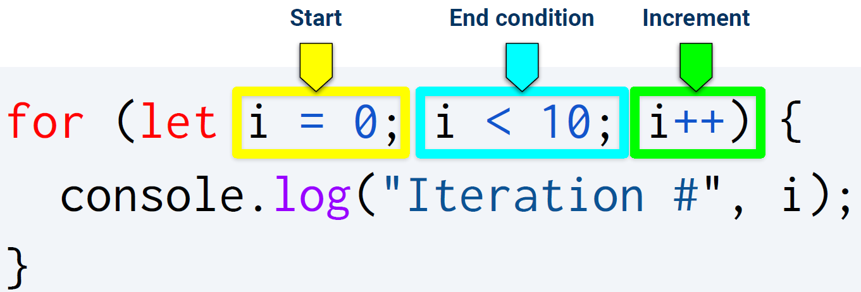

^ ++ means plus one

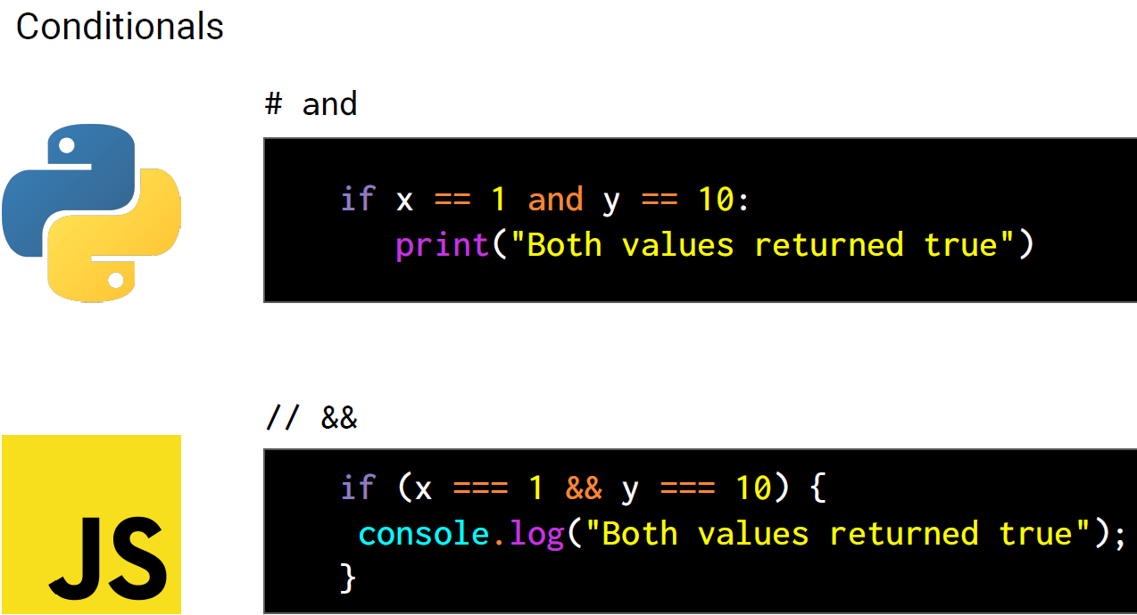

^ three equals signs and two ampersands.

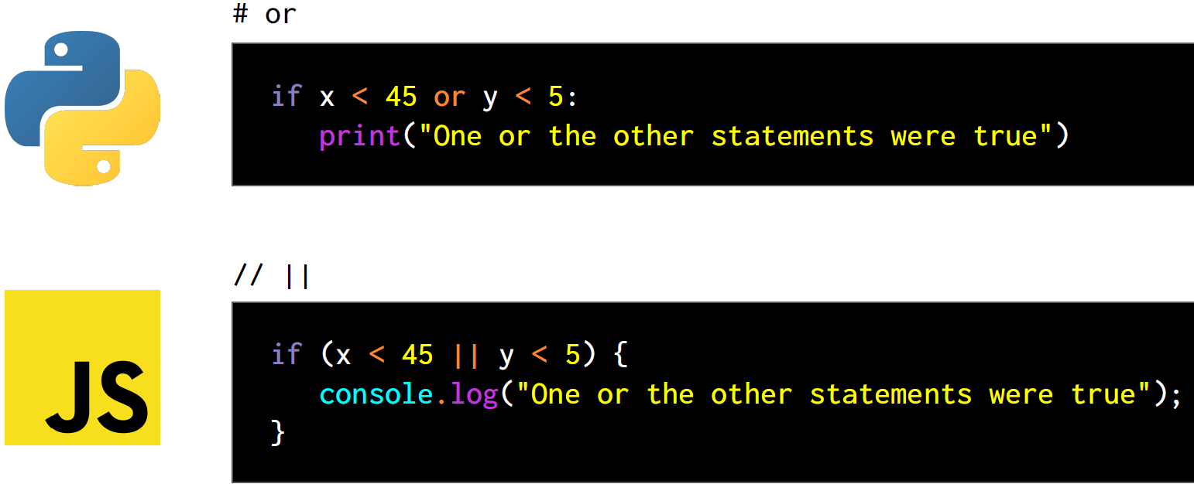

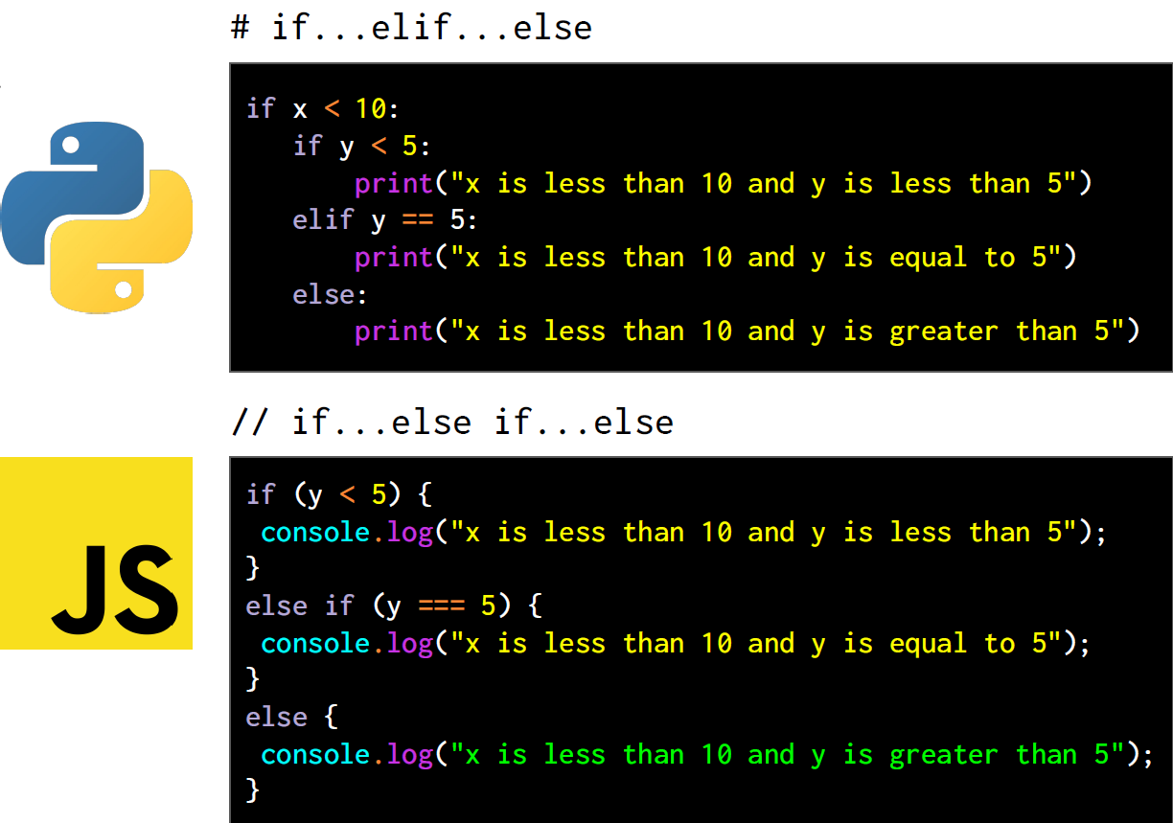

You can use an exclamation point (!) to negate a statement. It’s like saying “not”.

**Stu_ Iterations and conditionals solution:**

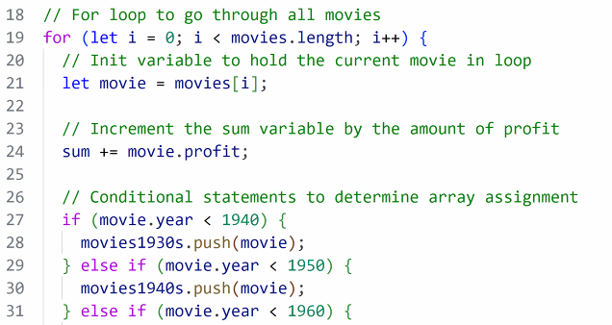

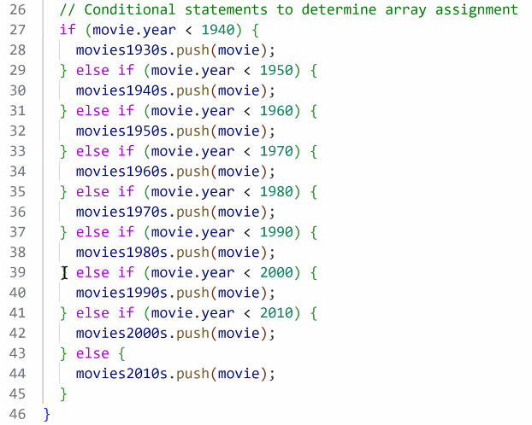

Multiple Traces Solution:

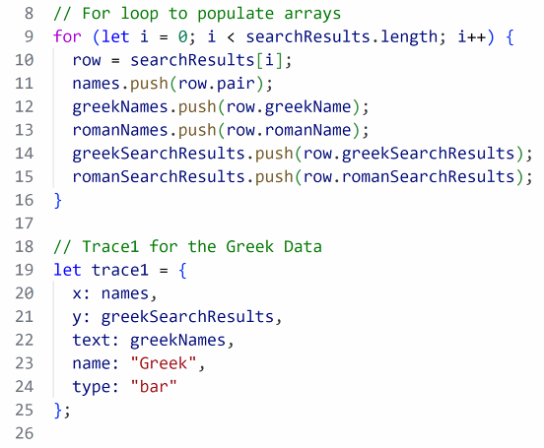

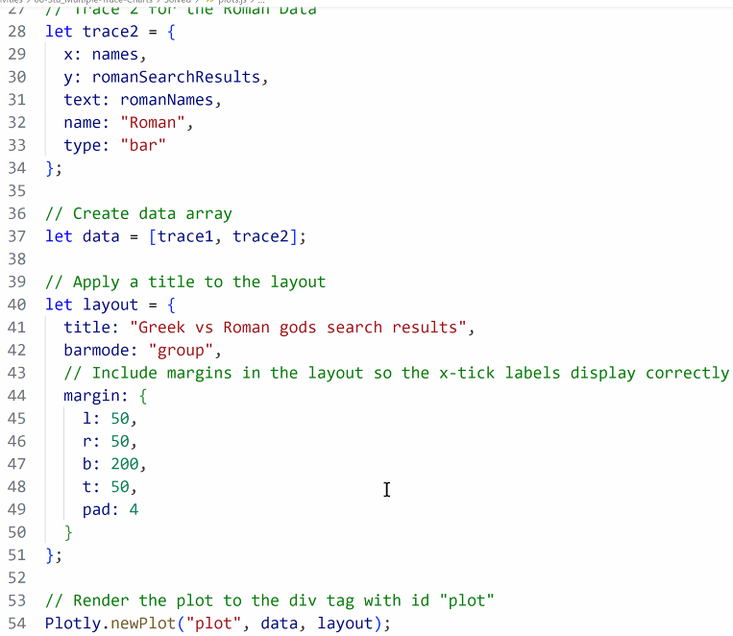

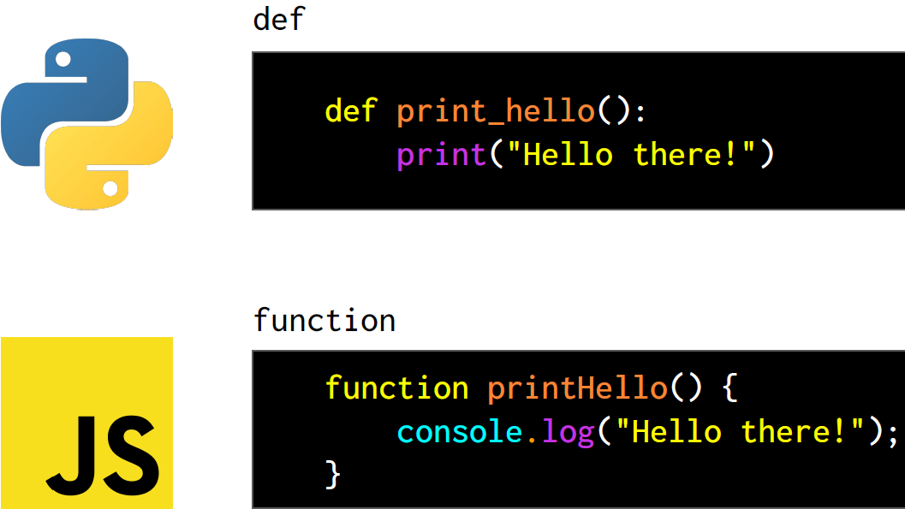

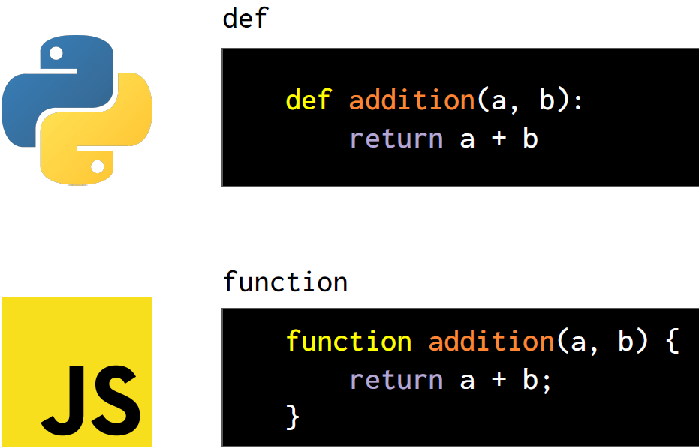

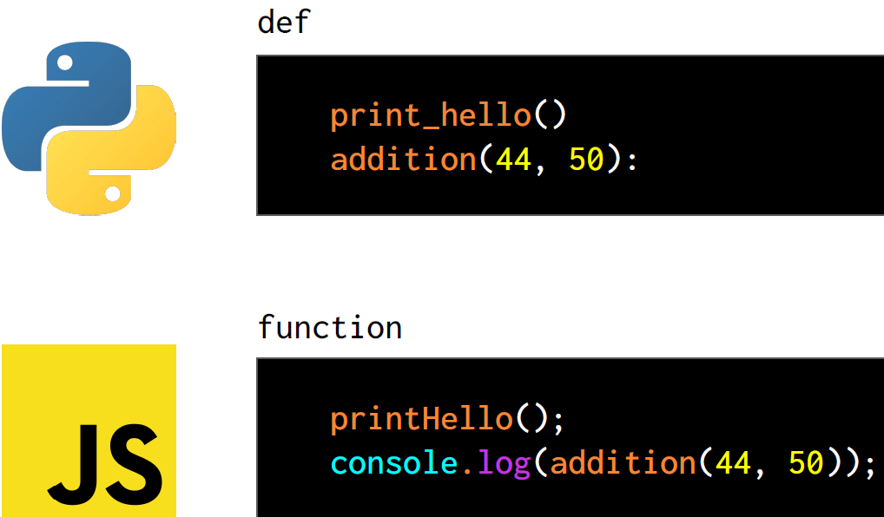

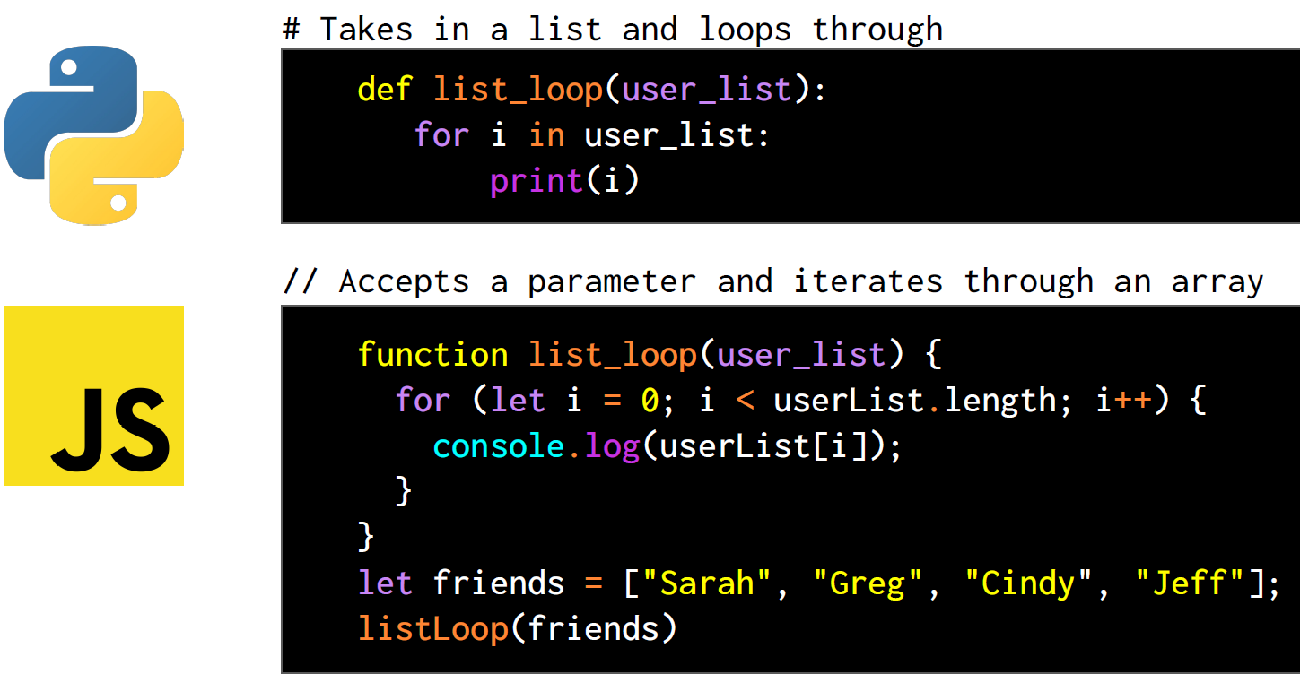

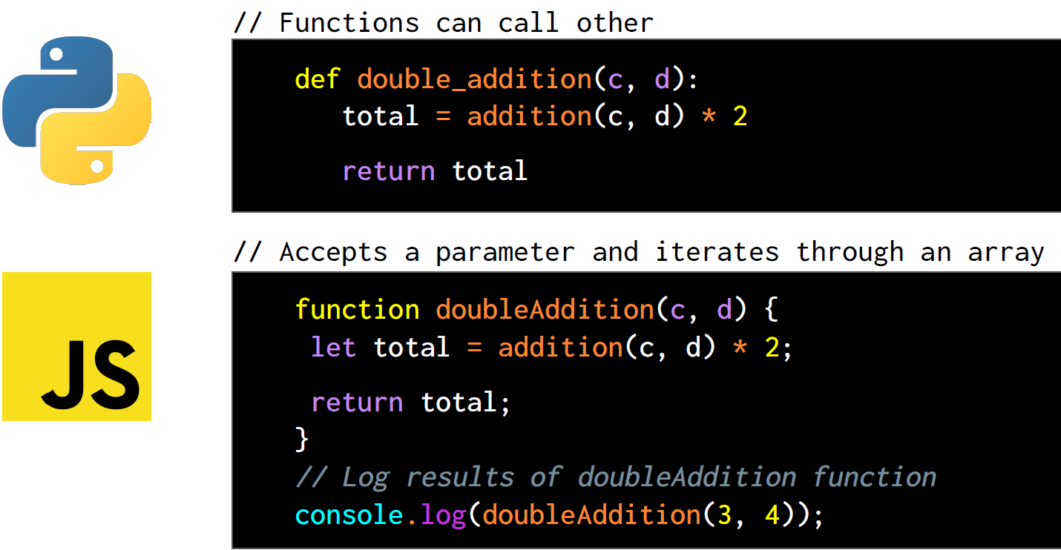

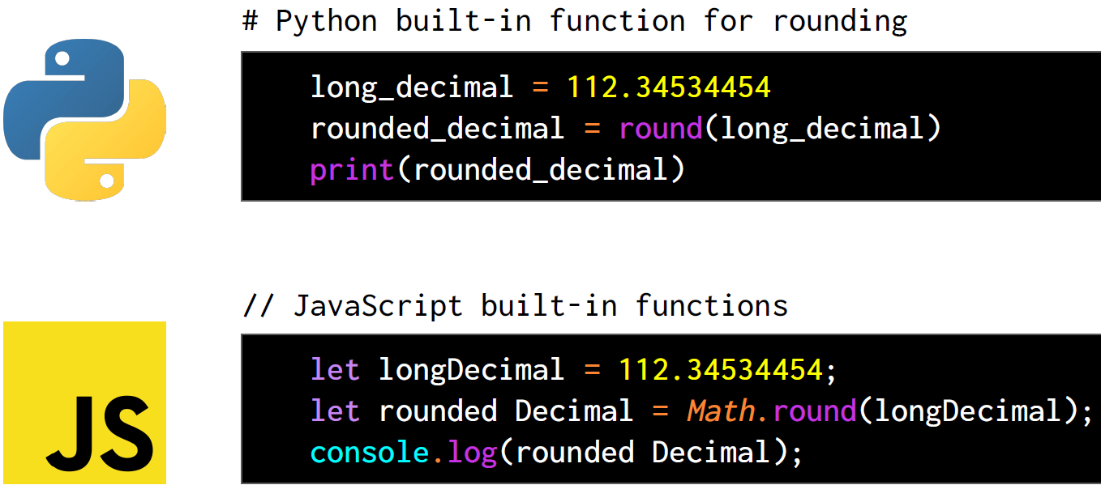

**Creating Functions Solution:**

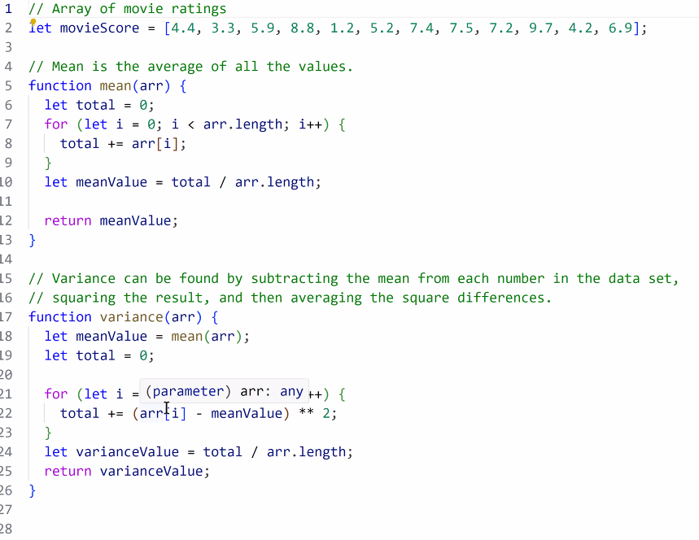

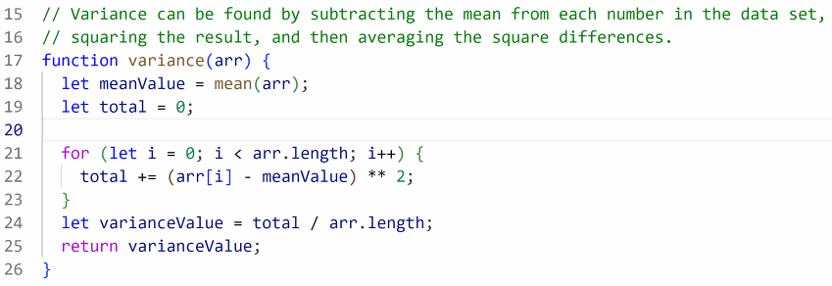

**Preprocessing Solution:**

